#### Mission Statement

**Meet the Team**

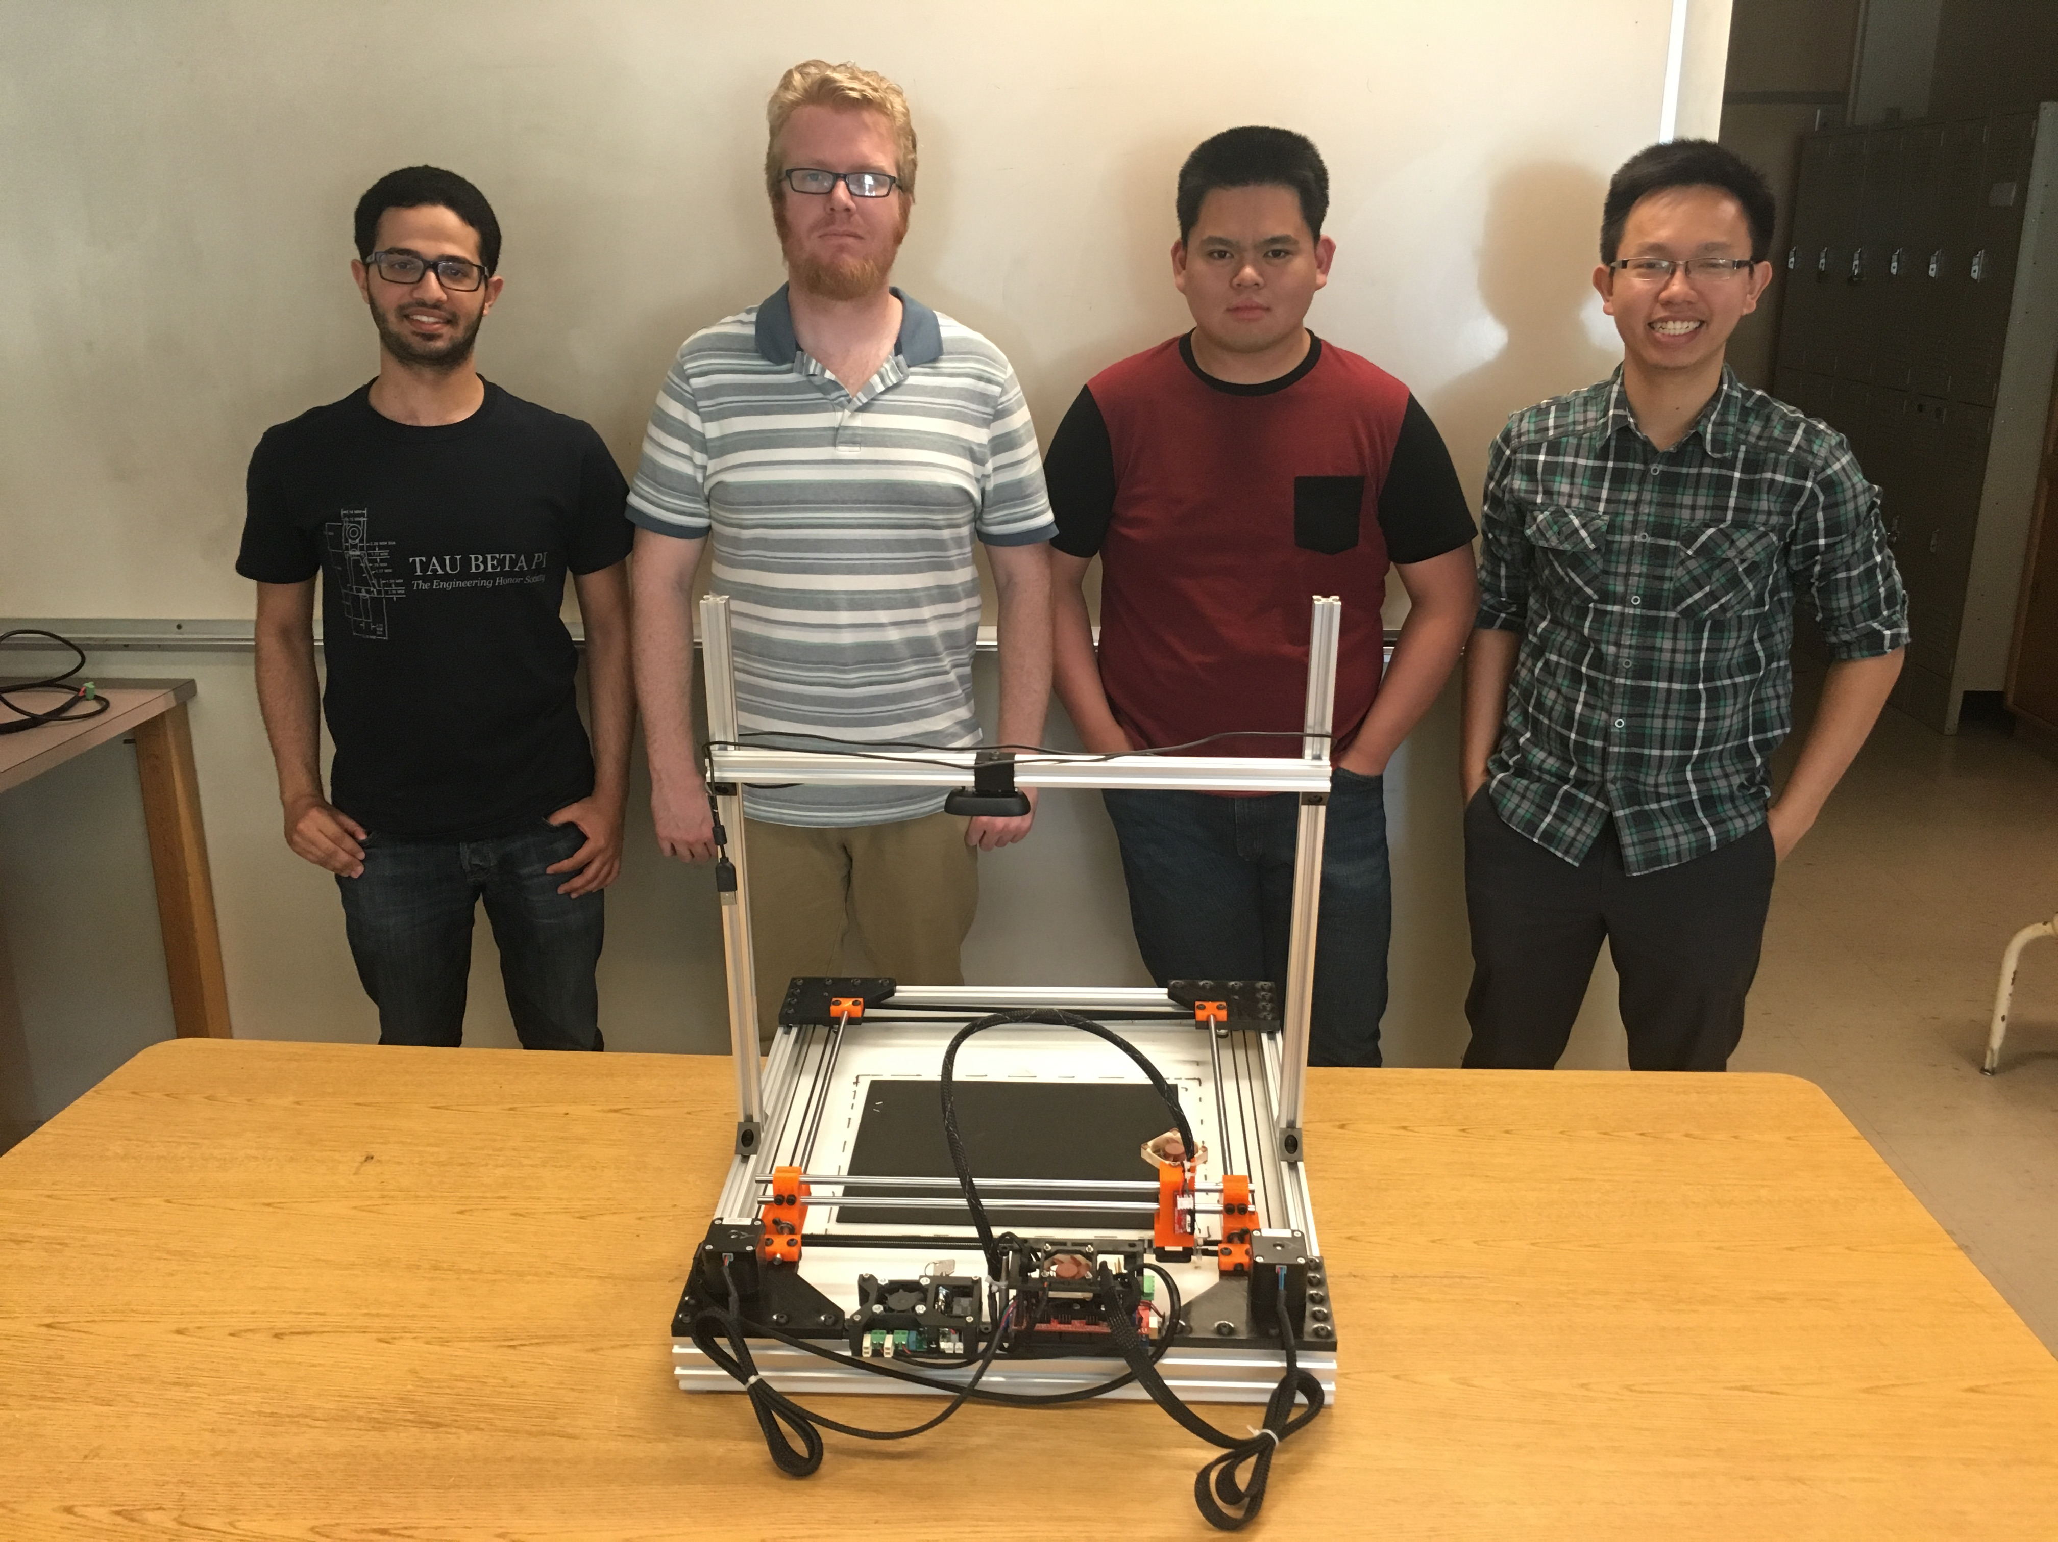

**Team Members-** From left to right: Ammar Ahmed, Thomas Bock, Michael Golez,

Tan Hua

**Ammar Ahmed-** Ammar is a senior, majoring in Electrical Engineering at Sacramento State University. His focus is in control systems with a small emphasis in Analog Design. His contribution towards the project was the development of the computer vision system. This system was implemented to get the dimension and location of the object in the working space.

Currently, he is the controls team lead of the Hornet Hyperloop club. Also, he is a tutor at the Math department at CSUS.

**Thomas Bock-** Thomas is a first semester senior majoring in Electrical Engineering at Sacramento State, with a focus on control systems.

His contribution to the project was the design and construction of the frame and linear motion system of the laser cutter. This system allows for accurate and reliable motion of the laser.

He is currently the President of the 3D Printing Club at CSUS

**Michael Golez-** Michael is a senior engineer at California State University, Sacramento, majoring in Electrical Engineering. His primary focus is Digital/Analog Systems with a small emphasis in Control Theory. In the design of the CNC laser system, his contributions include the powering and operation of the laser diode and laser control circuitry. This involved designing and implementing a constant current source that can operate the laser safely.

**Tan Hua-** Tan is a Communication System Engineer with a minor focus on Digital Signal Processing. Over the years at Sacramento State, he spent time practicing software development. Currently he is working as an I.T. support for the state. As a result, his main focus towards the project would be the software implementation towards controlling the CNC laser system.

**Q-Laser**

# CNC Laser Cutter/Engraver

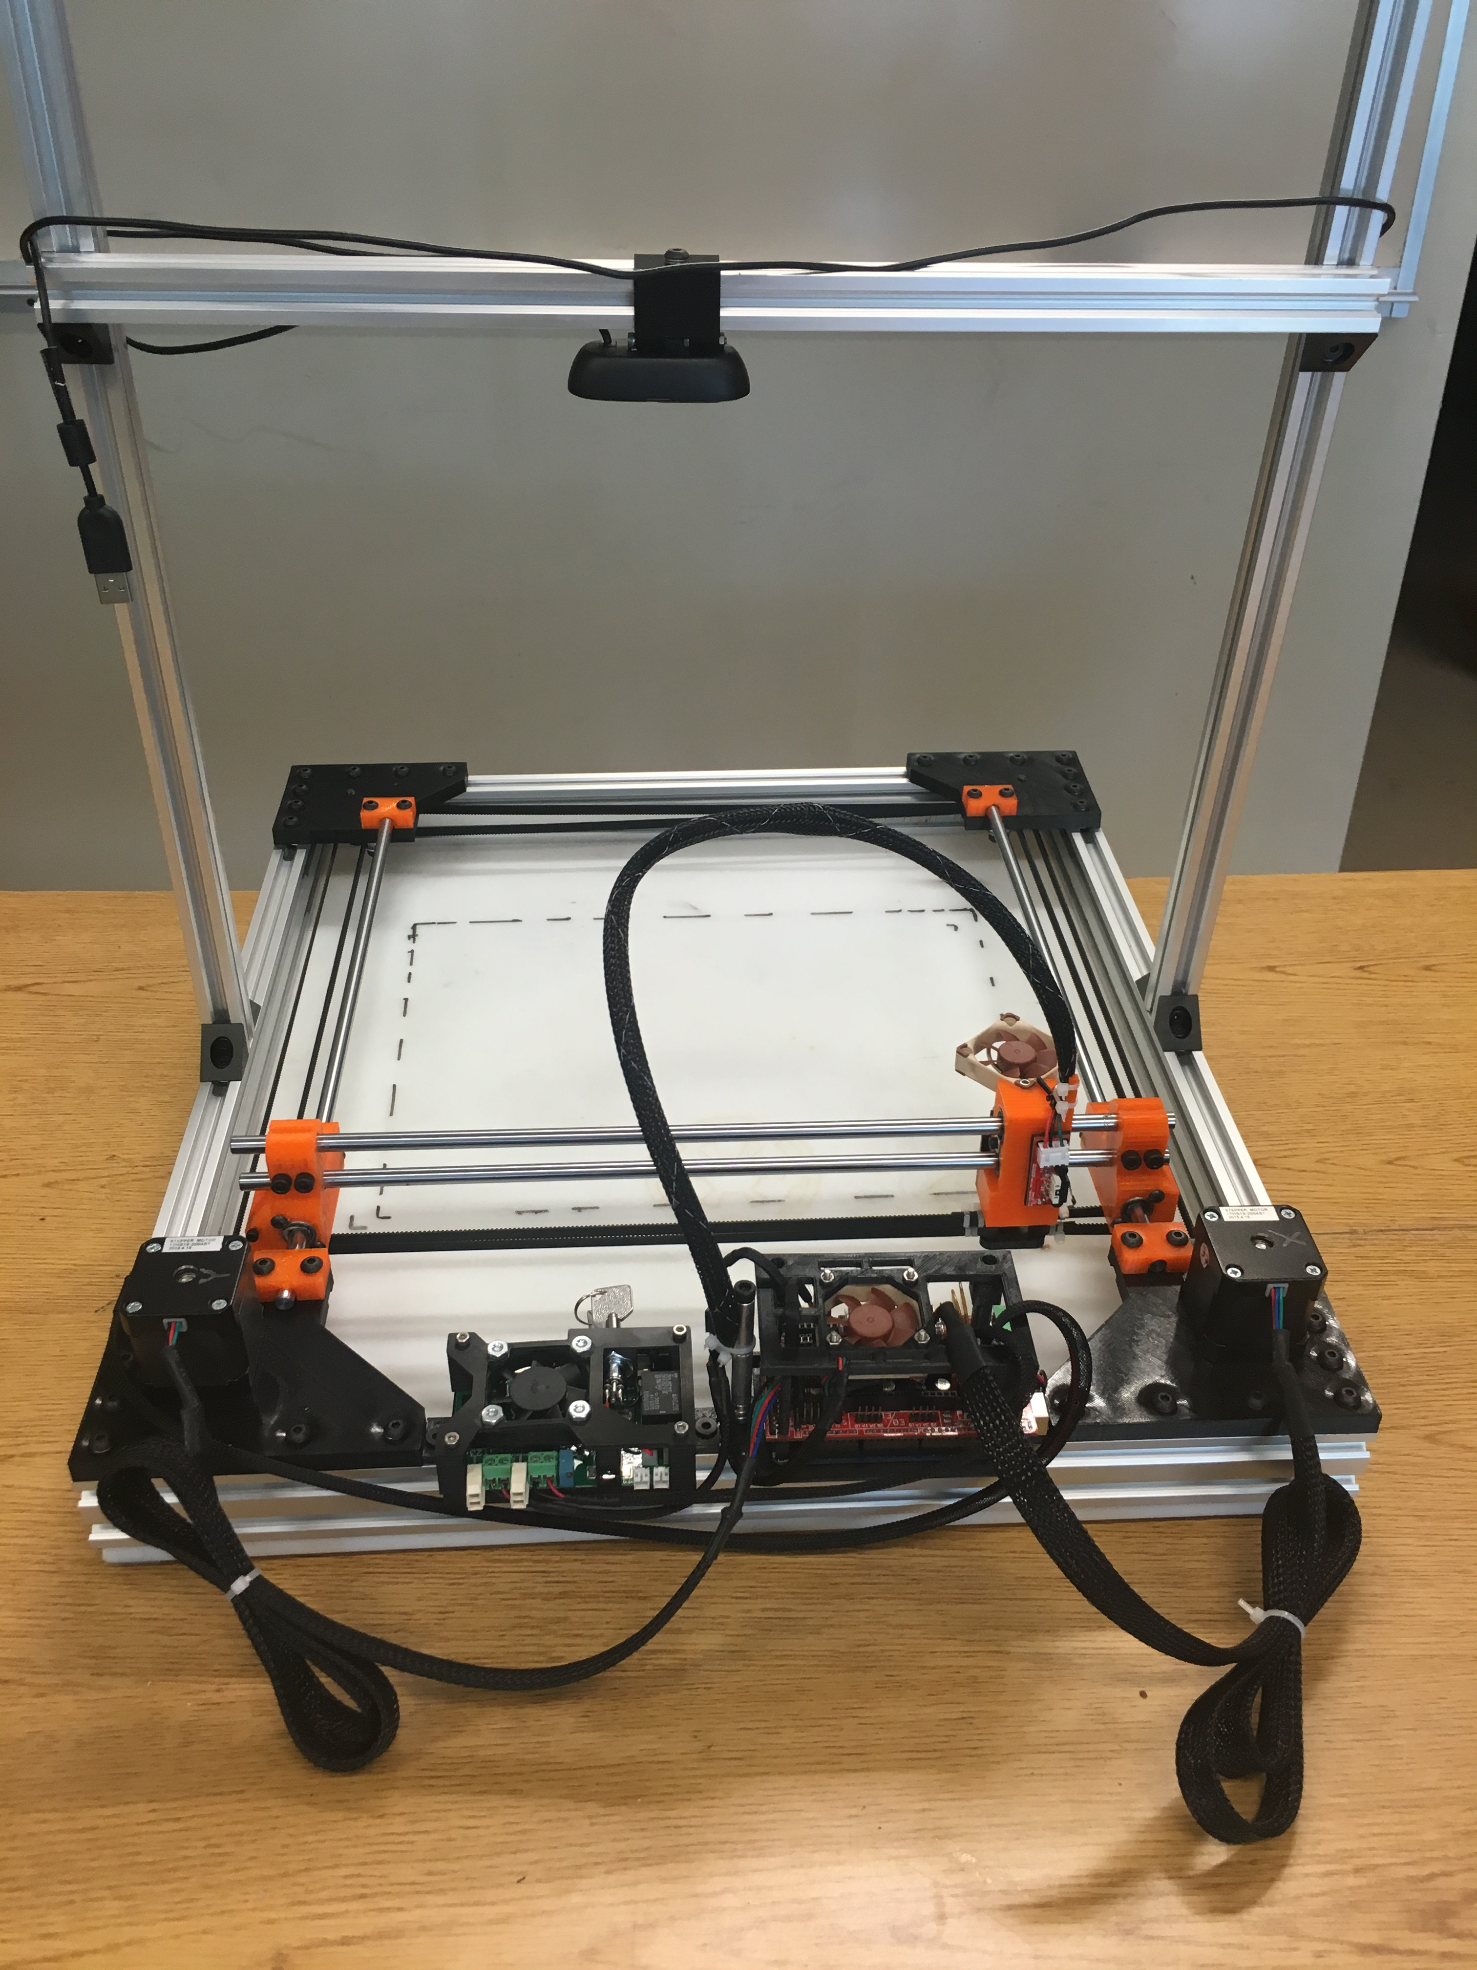



To create a low cost laser cutter/engraver for hobby and educational purposes.

California State University, Sacramento

Senior Design Project Prototype

Spring 2016

EEE193A/CPE190

#### Q-Laser CNC Laser System Operation